**Political ASylum & Immigration Awareness Night**

**Friday, January 25th 5 -7 p.m.**

Buckman Elementary 320 SE 16th St.

Family Friendly Event!

# An opportunity to learn about the political asylum process

* Write letters to individuals and families being held in detention centers
* Hear from local immigration organizations to find out how to get involved
* Information on affordable immigration lawyers
* Connect as a community
* Food Provided

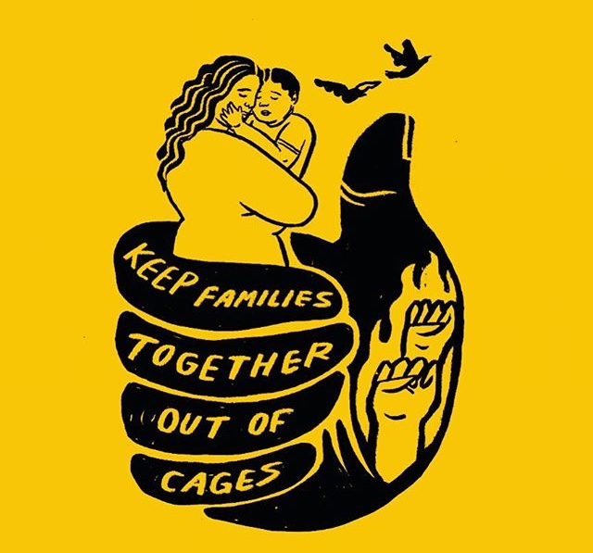

**Get Involved!**

**Jasmine Springs |Student Engagement and Equity Specialist | jsprings@gmail.com**